Machine Learning based Classification of Tomato Diseases using Texture Features on Plant Leaves
¹Niyati Samir Jain, ²Divya Dadarya, ³Aditya Sinha, ⁴Rajveer Singh Shekhawat ⁵Tarun Jain
^{1,2,3,4,5} Manipal University Jaipur
Jaipur, India
niyatijain00@gmail.com, divyadadarya@gmail.com,*adityasinha.1988@gmail.com
genieousrishi@gmail.com, rajveer.shekhawat.in@gmail.com, tarunjainjain02@gmail.com
Abstract. Indian economy majorly depends on agriculture and most of the family’s earnings depend on agricultural farming. Infected plants and crops cause a reduction in qualitative and quantitative yield. Therefore, identifying plant disease accurately is a challenging task. Infection usually occurs in parts like leaves, stems, and fruits. It is difficult to accurately identify the disease and the cure of disease with naked eyes. Here, Image Processing plays an important role. The diseases are the result of environmental changes, and it destroys a significant amount of crop production. The common diseases are caused by fungi, bacteria, and viruses, and due to adverse environmental conditions. Therefore, in the initial stage, detection and identification of a disease is the most important task. Most of the tomato leaves are attacked with fungi, bacteria, and viruses. The dataset used contains 200 images of infected leaves, which includes 100 images of late blight and early blight in tomato leaves, and 100 images of healthy leaves. We have used various machine learning classifiers along with texture features derived from grey level Co-occurrence Matrix for feature extraction. In the experimentation we have observed k-NN gave the best results under restricted conditions.
Keywords: Classification, Plant Disease, Machine Learning, Tomato Early Blight, Tomato Late Blight
- INTRODUCTION
One of the most frequently occurring diseases in tomato plants and is infamous for attacking stems, leaves as well as the fruit. It is also said to limit the yield of the crop to a great extent depending on the variety of crops and the climatic conditions. It is primarily caused by two fungi namely, Alternaria tomatophila and Alternaria solani. Initial signs of the infection include round brown spots. They later grow bigger in size creating concentric rings around them apart from turning the border-line tissue cells yellow. Another very alarming diseases in tomato crops is late blight. It is caused by a fungus, Phytophthora infectants. Its indication is the presence of huge brown patches that are often misinterpreted for dried leaves. Late blight can only be eliminated using a fungicide at an early stage else it goes on to ravage not only the plant itself but also the ones surrounding it. A good practitioner needs to be thorough with the requisite knowledge and signs and symptoms of the diseases he is working on. Also, just how farmers monitor plants continuously, several efforts have been made to design a dataset that is eligible enough to classify the diseases based just on images of leaves. The primary aim of these approaches is the detection and identification of the disease at a very early stage to come up with the required treatment in time. The approach we are using machine learning as well as computer vision to build and train a classifier model. This signifies the leap in technology that the world has taken and realizing that people in remote areas will also be able to be a part of this endeavor motivates a lot of computer scientists. Through this classifier, farmers will be able to identify the problem at an earlier stage, thus increasing the production and decreasing the later financial risks.

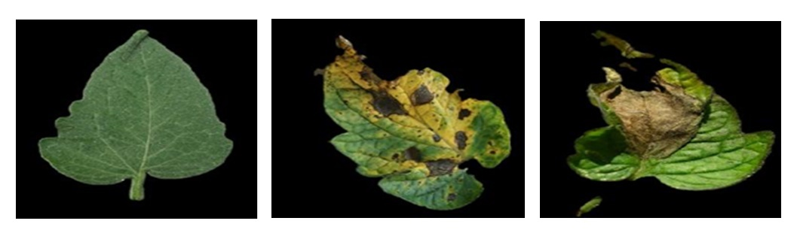 Fig. 1. Healthy tomato leaf, Tomato leaf infected with early blight, tomato Leaf infected with late blight
- LITERATURE REVIEW
Plant health monitoring using image processing and machine learning can broadly be classified in three major sub-domains, detection, quantification, and classification [2]. For detection, quantification, and classification of plant diseases specifically on leaves a lot of work has been done in the recent past [3-6]

Mohammed Brahimi (2017.) [1] proposed a deep learning model for the development of a classifier for the identification of diseases. He also proposed the idea of confinement of the infected areas of the image as it would be better to visualize and identify the disease. The dataset used by the author is the dataset published in good fellow Bengio, etc.
Al-Hiary (March 2011.),[2] proposed detection and classification of plant diseases using automation. In this approach, k different clusters of the pixels are formed on the basis of features. An Artificial Neural Network is used for this approach.
S Mohanty (2016),[3] proposed a deep learning CNN model for a dataset containing 54,306 images including both healthy leaves and infected leaves which covers 26 diseases. The trained model achieves an accuracy of 99.35%, demonstrating the practicability of this approach.

The above literature survey has explained the importance of early detection of leaf diseases. The research papers mentioned addresses all the developed methodologies or approaches to detect and acknowledge the existence of the plant diseases that would help the farmers to identify the diseases and find a solution to them at an early stage. This shows the importance of imaging using machine learning models in the agricultural field and related research work.
- METHODS AND METHODOLOGY
Classification of tomato leaves infected by various pathogens using Image Processing. 2 Classifications are performed – The First classification will be done to identify if the leaf is infected or not, and the Second classification will be done to identify that the leaf is infected from which pathogen. This study puts forward two important contributions in plant disease classification: Improvement in classification field using deep learning models: Deep Learning models are known to classify better than machine Learning models owing to their layered approach. Moreover, they can achieve incredible accuracy even on raw data without applying much feature engineering and they provide the chances of transfer learning from different tasks using pre-trained models on much larger datasets. More information on symptoms of any disease in the infected leaf: Our objective is extended to identifying the type and extent of the diseases simply using the images. This will prove to be a milestone in medical science as it offers a panacea for many problems without the involvement of agricultural experts.
  - Methods

In this study, we have used the Plant Village dataset to obtain the desired images. The dataset comprises 14,828 images of tomato leaves infected with nine diseases namely: Tomato Target Spot, Tomato mosaic virus, Tomato Yellow Leaf Curl Virus, Tomato Bacterial spot, Tomato Early blight, Tomato healthy, Tomato Late blight, Tomato Leaf Mold, Tomato Septoria leaf spot, Tomato Spider mites Two spotted spider mite.[8] We begin our project by focusing only on Late and Early blight diseases to test and approve algorithms. Also, we obtained the segmented images of the actual images in the dataset from GitHub repository of the author [24] which helped us skip the pre-processing at first and focus on essential segments such as the feature extraction techniques.
On exploring the many techniques available for feature extraction, we narrow down our options to the following list of algorithms:

Texture Feature Extraction
GRAY LEVEL CO-OCCURRENCE MATRIX (GLCM) is defined by a matrix that calculates the relation between two pixels at a time. The count of rows and columns in the matrix is equivalent to the count of gray levels (G) of the image. It calculates the occurrence of a specific value of pixels and offset occurs in any image. The different textural features which are derived using the GLCM matrix are: energy, entropy, contrast, homogeneity, correlation, dissimilarity, inverse difference moment, and maximum probability. [23,24]

Color Feature Extraction

COLOR SPACING is a conceptual tool for describing the way colors are represented. It can mean the use of a specific color model or system that turns colors into quantitative or statistical data for analysis. A normal grayscale image can be defined by only one matrix, but a color image is composed of three primary and multiple combination colors which can be used for deeper research.

For the classification, we worked on the following 5 different classification methods:

SVM (Support Vector Machine)

The main objective of SVM is to find the decision boundary/hyperplane which separates n-dimensional space into different categories or classes. Hyperplanes are created with the help of extreme points which are chosen by our SVM model. The data points which are closest to the hyperplane are called Support Vectors and they also affect the position of the hyperplane.

We applied 3 different types of kernels in the classifier:
Linear kernel is the most basic and fastest kernel in the SVM classifier. RBF (Radial Basis Function) kernel is the most preferred kernel in SVM and best for classifying between non-linear data. Sigmoid kernel is mostly preferred for neural networks as it works as an activation function for neurons. [20]

KNN (K-Nearest Neighbors)

This algorithm among many classifier models is simpler and can be implemented for both regression as well as classification. In this, clusters of different data types are formed based on their similarity. KNN stores all the new data and classifies them based on similarity, thus improving the efficiency. For the value for n_neighbors, we used The Elbow Method. [1]

Decision Tree Classification

Another supervised algorithm, it looks similar to a tree and has both roots and branches based on the stepwise decisions it takes. It can overcome the bias to a level since it follows a tree structure therefore it is easy to find results with just two options in front.[15]

Random Forest Classification

There might be overfitting when the decision tree algorithm is applied, so to avoid this we use random forest classification. This technique combines multiple classifiers, primarily decision trees to perform more convoluted problems. This improves the efficiency of the model and takes less training time compared to other models.[22]

Naïve Bayes Classification

This classification method, based on Bayes theorem, can be used for a dataset divided into 2 or more classes. This algorithm is fast and easy to build, and by applying this algorithm it is possible to tell how the occurrence of a particular event affects the probability of another event. [23]
  - Methodology

We approach the problem using a four-step architecture which is:
● Image pre-processing: Digital Image Pre-processing is paramount in an Image recognition model. The input images obtained from the dataset are captured in varied conditions, devices, and sources due to which they often suffer from varying contrast and noise which makes it difficult to extract features. Hence, eliminating disturbances and choosing the suitable color model which will enable us in feature extraction
● Segmentation: Segmentation of an image is extracting the region of interest (ROI) which in our case is the leaf from the background.
● Feature extraction: Feature vectors are constructed using various attributes of an image like color, shape, and dimensions to study and detect diseases and henceforth classify them accordingly. It forms the primary step in the image Classification model.
● Classification model: In the final stage, we obtain the results, i.e if the leaf is infected or not or if yes, then with which infection using classification neural network model like CNN, ANN etc.

The work starts with understanding the purpose, objectives, and approach of our problem statement. For that, we studied the dataset components, history, and previous works. We also went on to read numerous research papers published under the dataset from where we were able to slack off a set of few relevant works. We then read those shortlisted papers in detail and jotted down keywords that can be utilized to devise a methodology for our project and maintained that in an excel sheet along with a brief description. Once our approach of work was finalized, we started studying effective techniques in feature extraction that will prove useful to detect and classify diseases using images from our dataset. We then tried our hands on the code to implement those algorithms on sample images and analyzed the outcomes.

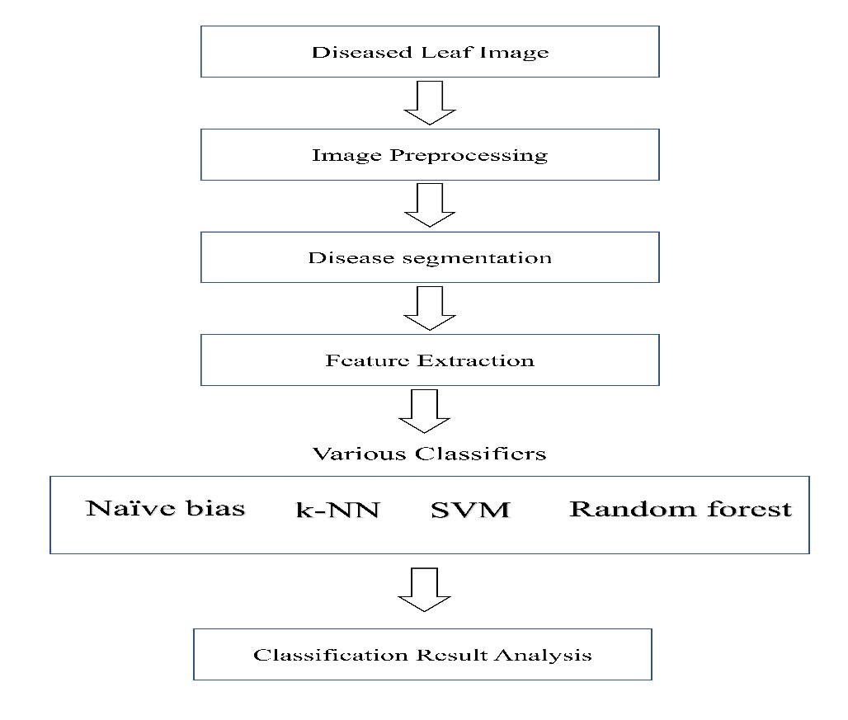

Fig 2. Block diagram of the methodology

We narrowed down to two feature extraction techniques –
- GLCM (Gray-Level Co-occurrence Matrix)
- Color channel
There are originally 22 texture features derived from the GLCM, we optimized the feature set using cross correlation analysis and narrowed down to the following set of the most important features for classification:
- Contrast: It is used to understand the difference in intensities among neighboring pixels.
- Dissimilarity: Dissimilarity calculates distance between two pairs of pixels in the region of interest.
- Homogeneity: This feature refers to the closeness of the distribution of pixels.
- Energy: Energy is synonymous to homogeneity and points to the statistical measure of randomness.
- Correlation: It computes the joint probability occurrence of the selected pixel pairs.
- ASM: ASM stands for angular second moment representing the uniformity of distribution of grey level in the image.

Initially, we thought of doing the first classification i.e., classification between healthy and infected leaves, with the help of color-spacing technique but was unable to do so as it was not coming down to a particular conclusion. Thereafter we decided to store the values of all the GLCM features in an excel sheet and then use that as input of the network and then classify it using different classification methods like SVM Classification, KNN Classification, Kernel SVM Classification (rbf and sigmoid kernels), Naïve Bayes Classification, Random Forest Classification, Decision Tree Classification.

- RESULT AND DISCUSSION

We have tested the results of the various classifiers on numerous combinations of training and testing datasets, some are discussed below. We tested the classifiers on two combinations of training and testing datasets so as to increase the confidence and got a very detailed result analysis of the same. We created a dataset from Plant Village Dataset of 200 segmented images for each classification and divided our dataset in a ratio of 7:3 for the training set and test set respectively.

  - Dataset: 140 images in Training Set and 60 images in Test set

SVM:
Kernel = Linear
Accuracy is = 78.33333333333333 %
F1 measure = 79.36507936507937 %
MCC Accuracy = 56.95214286468868 %
. 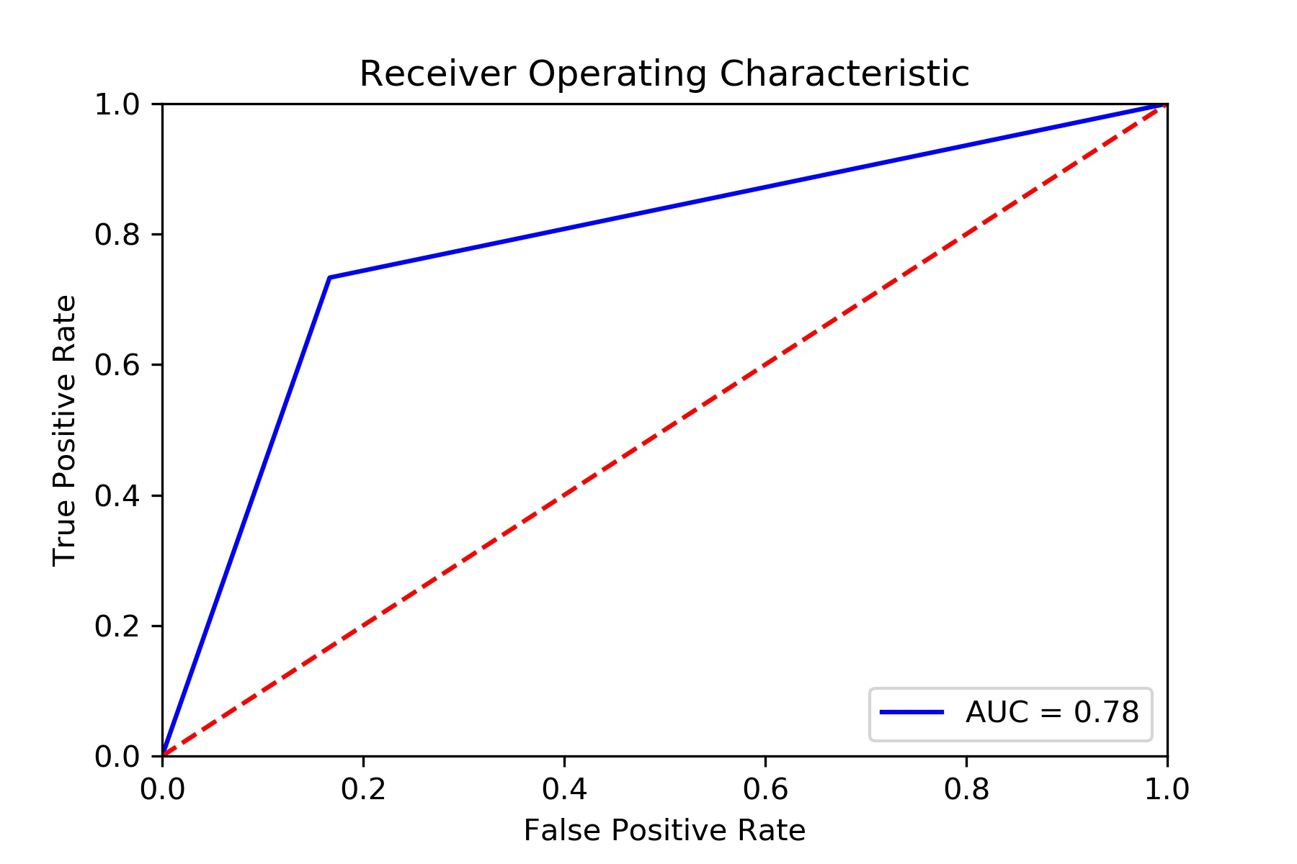
Fig. 3. ROC for SVM (linear kernel) based classification

Kernel = RBF
Accuracy is : 76.66666666666667 %
F1 measure = 78.78787878787878 %
MCC Accuracy = 54.433105395181734 %

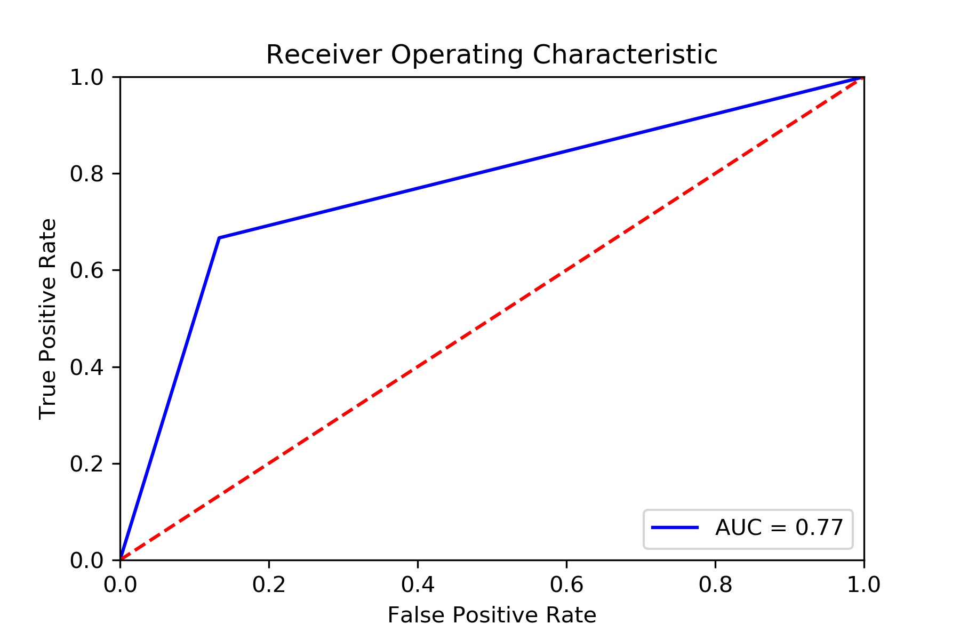

Fig. 4. ROC for SVM (rbf kernel) based classification

KNN: (n_neighbors = 3)
Accuracy is: 81.66666666666667 %
F1 measure = 83.5820895522388 %
MCC Accuracy = 65.1311611681508 %
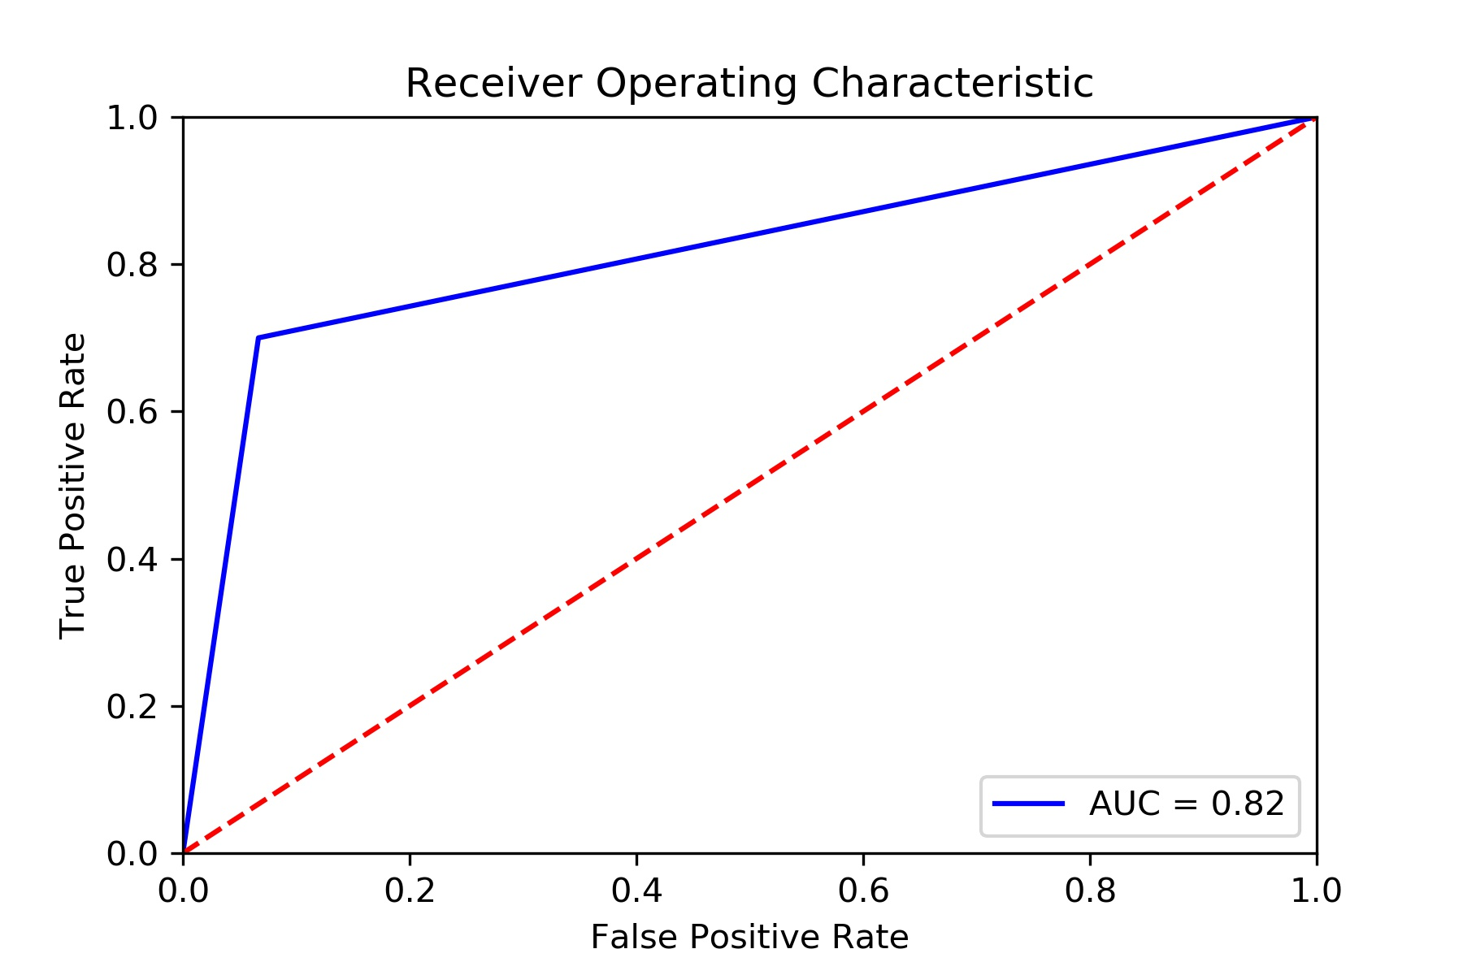
Fig. 5. ROC for KNN based classification

RANDOM FOREST: (n_estimators = 5)
Accuracy is: 75.0 %
F1 measure = 77.61194029850746 %
MCC Accuracy = 51.419337764329576 %
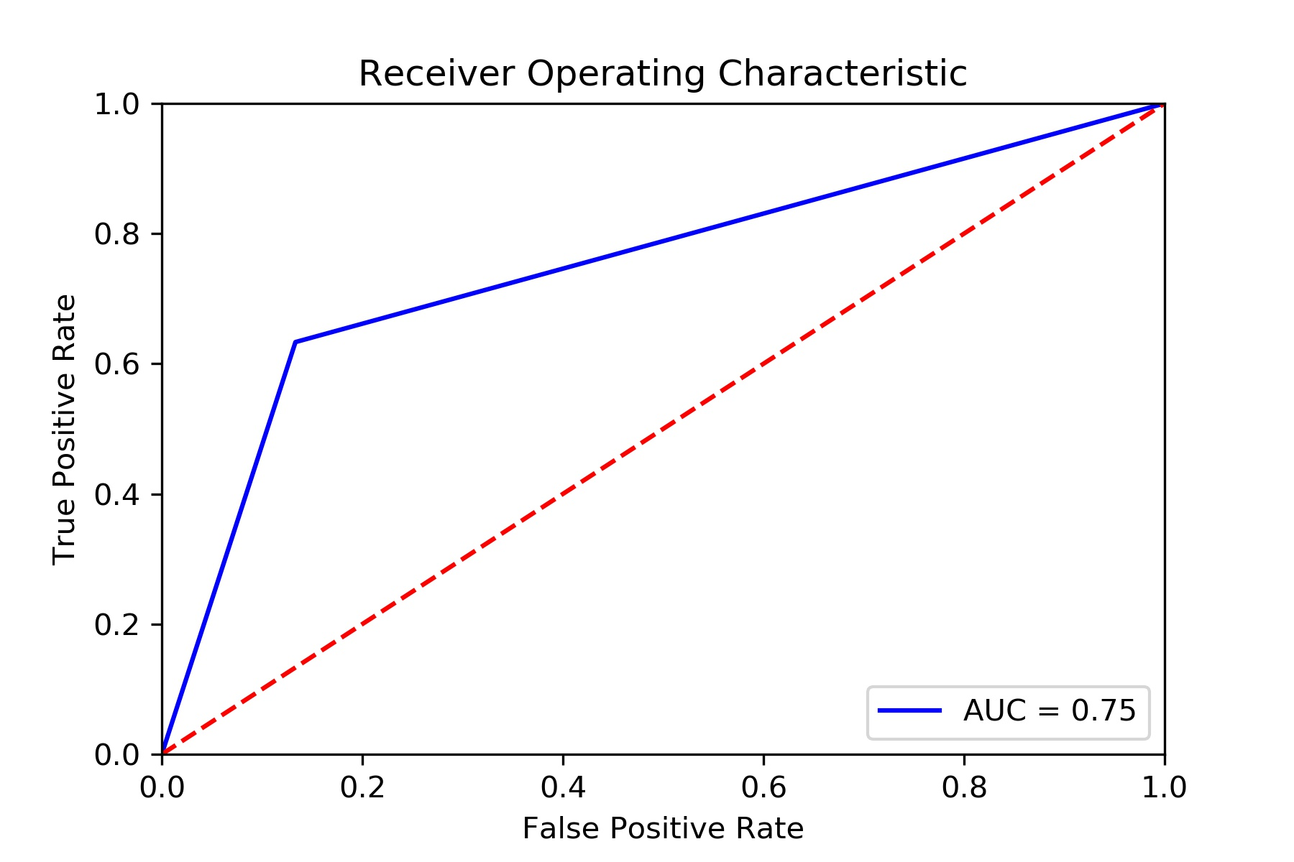
Fig. 6. ROC for random forest-based classification

The above classification methods were tested on Plant Village Dataset containing images of tomato leaves infected by several diseases. We made a dataset of 200 images containing 100 images of Early Blight and 100 images of Late Blight. The dataset was divided into a training set and test set with 7:3 ratio respectively. After applying the dataset, KNN gives the best accuracy of 81.67%, therefore KNN is the best and preferred classification method for classifying between Early Blight and Late Blight.
  - Dataset: 140 images in Training Set and 60 images in Test Set
SVM:
Kernel = Linear
Accuracy is: 76.66 %
F1 measure = 75 %
MCC Accuracy = 53.81 %

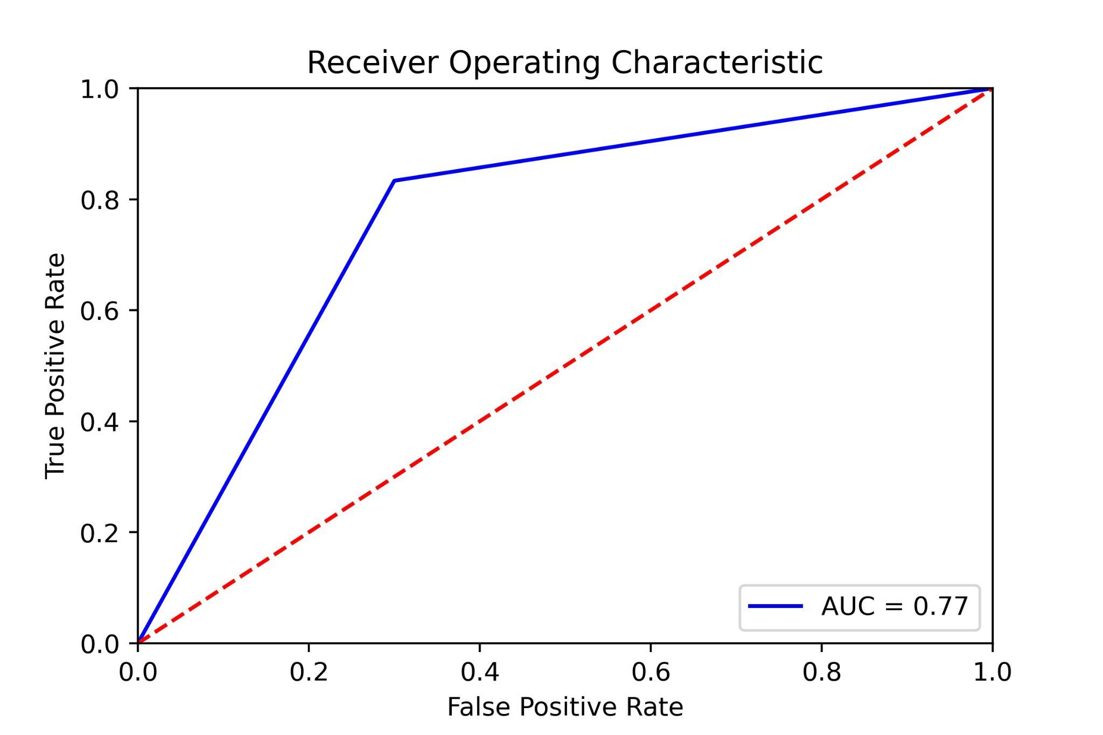
Fig. 7. ROC for SVM based classification

Kernel = RBF
Accuracy is: 80.0 %
F1 measure = 76.92 %
MCC Accuracy = 62.25 %
. 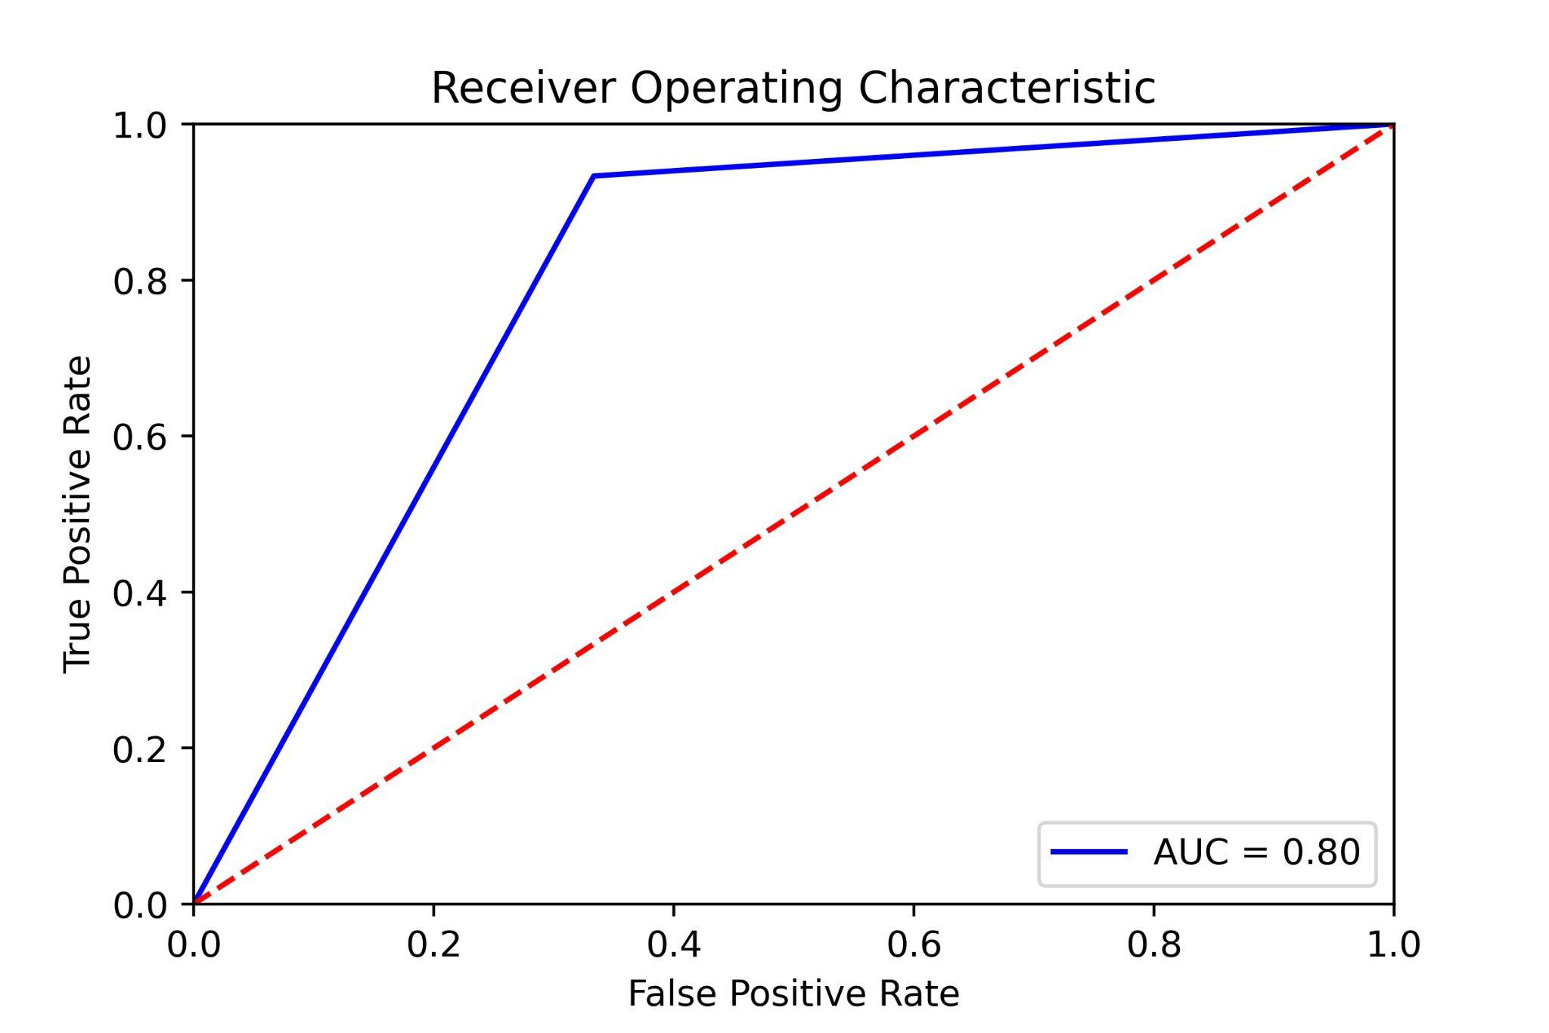
Fig. 8. ROC for SVM (rbf kernel) classification

NAÏVE BAYES:
Accuracy is: 76.66%
F1 measure = 73.076 %
MCC Accuracy = 55.33 %
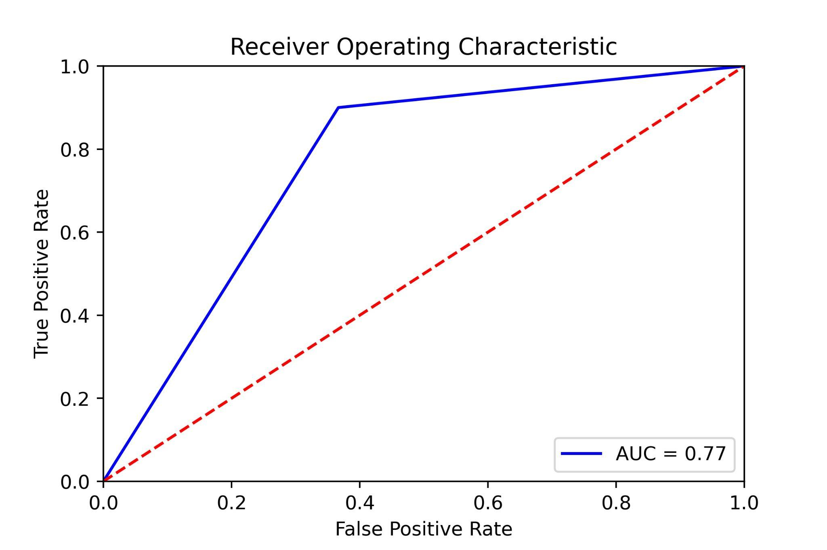
Fig. 9. ROC for naïve bayes classification

The above classification methods were tested on a dataset of 200 images containing 100 images of Healthy Tomato leaves images and 100 images of Infected Leaves, containing 50 images of Early Blight and 50 images of Late Blight. The dataset was divided into a training set and test set with 7:3 ratio respectively. After applying the dataset, RBF kernel SVM gives the best accuracy of 80%, therefore RBF SVM is the best and preferred classification method for classifying between Healthy Leaves and Infected Leaves. Classifier results may be seen in fig. 10.

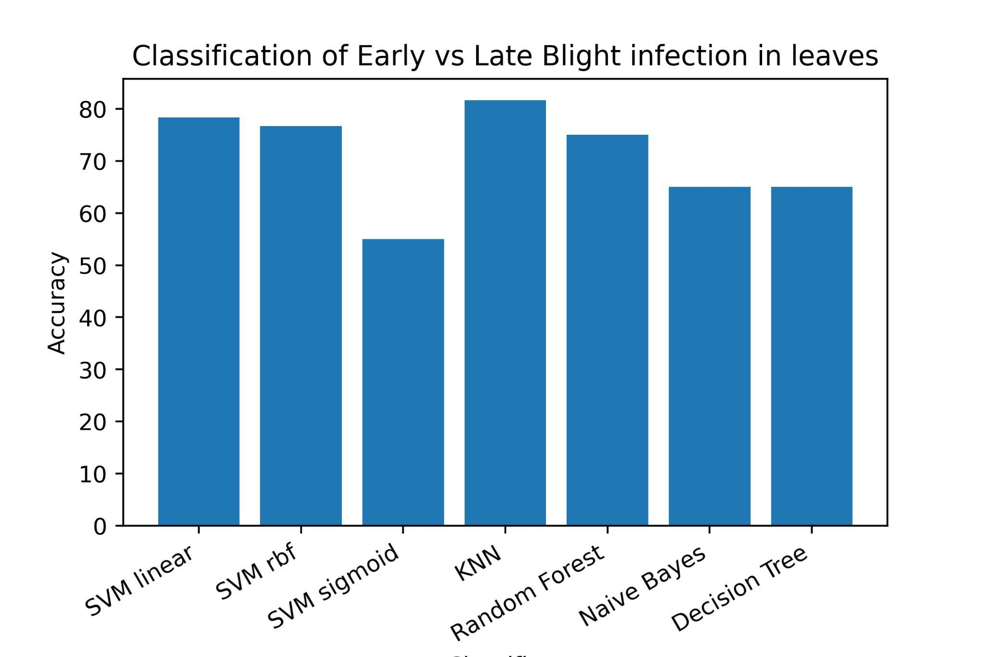
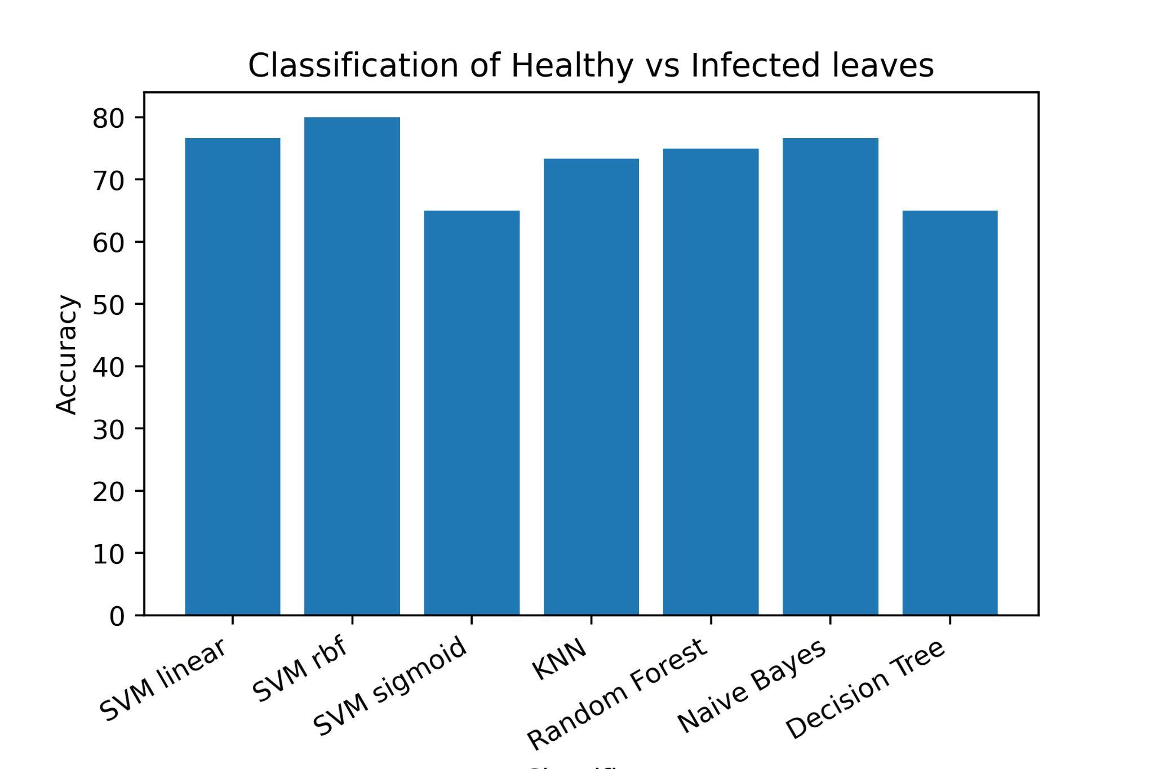
Fig. 10. Summary of results obtained by different classification methods.
- CONCLUSION
All these approaches and methods use Machine Learning and Computer Vision to build a classifier to detect the diseases using the image of just the leaf, which signifies the leap in technology that the world has taken and realizing that people in remote areas will also be able to be a part of this endeavor motivates a lot of computer scientists. Through this classifier, farmers will be able to identify the problem at an earlier stage, thus increasing the production and decreasing the later financial risks.

References
- Brahimi, M., Boukhalfa, K., & Moussaoui, A. (2017). Deep learning for tomato diseases: classification and symptoms visualization. Applied Artificial Intelligence, 31(4), 299-315.
- Sinha, Aditya, and Rajveer Singh Shekhawat. "Review of image processing approaches for detecting plant diseases." IET Image Processing 14.8 (2020): 1427-1439.
- Sinha, Aditya, and Rajveer Singh Shekhawat. "A novel image classification technique for spot and blight diseases in plant leaves." The Imaging Science Journal 68.4 (2020): 225-239.
- Bai, X., Li, X., Fu, Z., et al.: ‘A fuzzy clustering segmentation method based on neighborhood grayscale information for defining cucumber leaf spot disease images’, Comput. Electron. Agric., 2017, 136, pp. 157–165
- Barbedo, J.G.A., Godoy, C.V.: ‘Automatic classification of soybean diseases based on digital images of leaf symptoms. Embrapa Soja-Artigo em anais de congresso (ALICE), Ponta Grossa, Brazil, 2015
- Gharge, S., Singh, P.: ‘Image processing for soybean disease classification and severity estimation’, in Shetty, N.R., Prasad, N.H., Nalini, N (Eds.): ‘Emerging research in computing, information, communication and applications’ (Springer, New Delhi, India, 2016), pp. 493–500
- Al-Hiary, H., Bani-Ahmad, S., Reyalat, M., Braik, M., & Alrahamneh, Z. (2011). Fast and accurate detection and classification of plant diseases. International Journal of Computer Applications, 17(1), 31-38.
- Mohanty, S. P., Hughes, D. P., & Salathé, M. (2016). Using deep learning for image-based plant disease detection. Frontiers in plant science, 7, 1419
- Zhang, S., Zhu, Y., You, Z., et al.: ‘Fusion of superpixels, expectation maximization and PHOG for recognising cucumber diseases’, Comput.Electron. Agric., 2017, 140, pp. 338–347
- Maharlooei, M., Sivarajan, S., Bajwa, S.G., et al.: ‘Detection of soybean aphids in a greenhouse using an image processing technique’, Comput. Electron. Agric., 2017, 132, pp. 63–70
- Noble, W. S. (2006). What is a support vector machine? Nature biotechnology, 24(12), 1565-1567.
- Sutton, O. (2012). Introduction to k nearest neighbour classification and condensed nearest neighbour data reduction. University lectures, University of Leicester, 1.
- Biau, G., & Scornet, E. (2016). A random forest guided tour. Test, 25(2), 197-227.
- Quinlan, J.R. Induction of decision trees. Mach Learn 1, 81–106 (1986). https://doi.org/10.1007/BF00116251
- Rish, I. (2001, August). An empirical study of the naive Bayes classifier. In IJCAI 2001 workshop on empirical methods in artificial intelligence (Vol. 3, No. 22, pp. 41-46).
- Mohanaiah, P., Sathyanarayana, P., & GuruKumar, L. (2013). Image texture feature extraction using GLCM approach. International journal of scientific and research publications, 3(5), 1-5.
- Hall-Beyer, M. (2000). GLCM texture: a tutorial. National Council on Geographic Information and Analysis Remote Sensing Core Curriculum, 3, 75.
- Plataniotis, K. N., & Venetsanopoulos, A. N. (2013). Color image processing and applications. Springer Science & Business Media.
- Cristianini N., Ricci E. (2008) Support Vector Machines. In: Kao MY. (eds) Encyclopedia of Algorithms. Springer, Boston, MA. https://doi.org/10.1007/978-0-387-30162-4_415
- Breiman, L. Random Forests. Machine Learning 45, 5–32 (2001). https://doi.org/10.1023/A:1010933404324
- Hand, D. J., & Yu, K. (2001). Idiot's Bayes—not so stupid after all?. International statistical review, 69(3), 385-398.
- Verma, Vivek K., and Tarun Jain. "Soft-Computing-Based Approaches for Plant Leaf Disease Detection: Machine-Learning-Based Study." Applications of Image Processing and Soft Computing Systems in Agriculture. IGI Global, 2019. 100-113.
- Verma, Vivek K., and Tarun Jain. "Machine-Learning-Based Image Feature Selection." Feature Dimension Reduction for Content-Based Image Identification. IGI Global, 2018. 65-73.
- Mohanty SP(2016), Plant Village-Dataset https://github.com/spMohanty/PlantVillage-Dataset Accessed on 8th August 2021

